

Hajee Mohammad Danesh Science and Technology University

Project Name:
Contact Pro 2.1.4

Course Code: CSE 152
Course Title: Structured Programming Language (Sessional)

Submitted by:

MD FAHAD
ID :1802076

Objective of the project:
The project contains a multiuser login system with each individual having a separate database to enter his/her contact information. And to compute the distance between the user and the contact.

General Objective:
To store user data like a phone book and also provides an approximate distance for each entered contact.

Specific Objective:
Computing the distance between the user and his/her stored contacts.

Inspirations of the Project
A smartphone phone-book inspired me and also the advantages of google map helped me to provide the distance for each city.

Description of the project
This is for everyday use where people can store their contact information. It is a multi-user login system where each user will be able to store his/her contact information and also know the distance between each contact.
In the project there is various files used which contains the details of the stored contact.
It also uses a weighted graph of each city as node and the verteses points to the user and stored individual’s city to computes the distance.

Advantages:
This is for everyday use where people can store their contact information. It is a multi-user login system where each user will be able to store his/her contact information and also know the distance between each contact.
People of all age can use it and store their necessary contact information and also keep a track of their contacts.

Functionalities:
The project provides the below functionalities
- Storing data
- Name
- Mobile Number
- Phone Number
- Email Address
- Home Town
- Computing distance
- Computing distance between the user and the stored contact.

Technical Description:

Technical functionalities or options:
- First Phase
- Login (Login to previous registered account).
- Register (Register as a new user).
- About (Information about the software).
- Second Phase
- Add Contact
- View Contact
- Provides the contact information.
- Computes distance.

Technical Tools Used:
- Language: C.
- IDE: Code blocks.
- Text files: ‘.txt’ files.

Data Storage:
Data are stored in “.txt” files in the computer.

Project’s Internal Structure
Flowchart

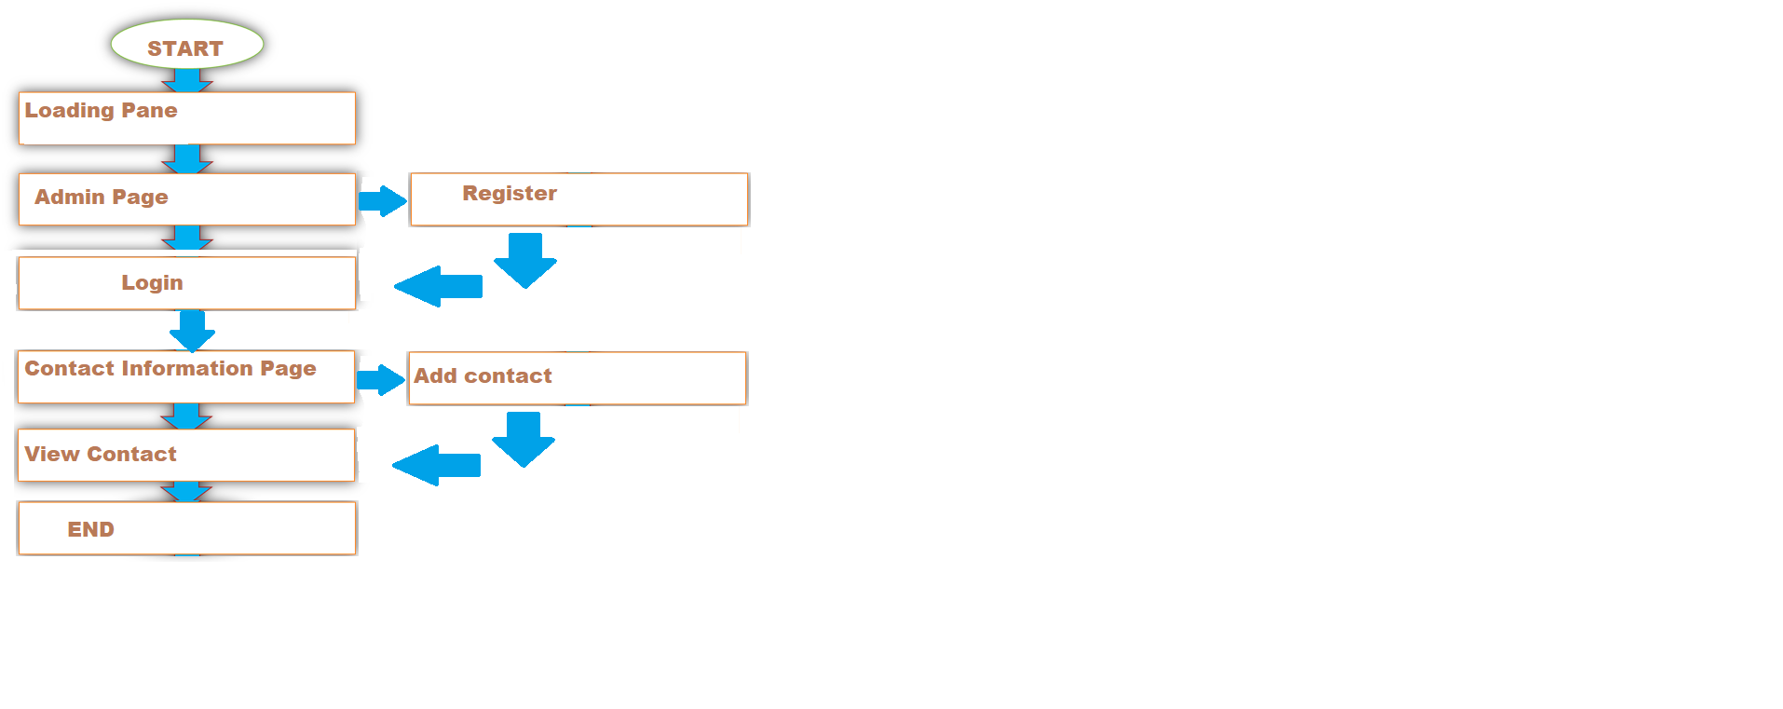

Output of the Project

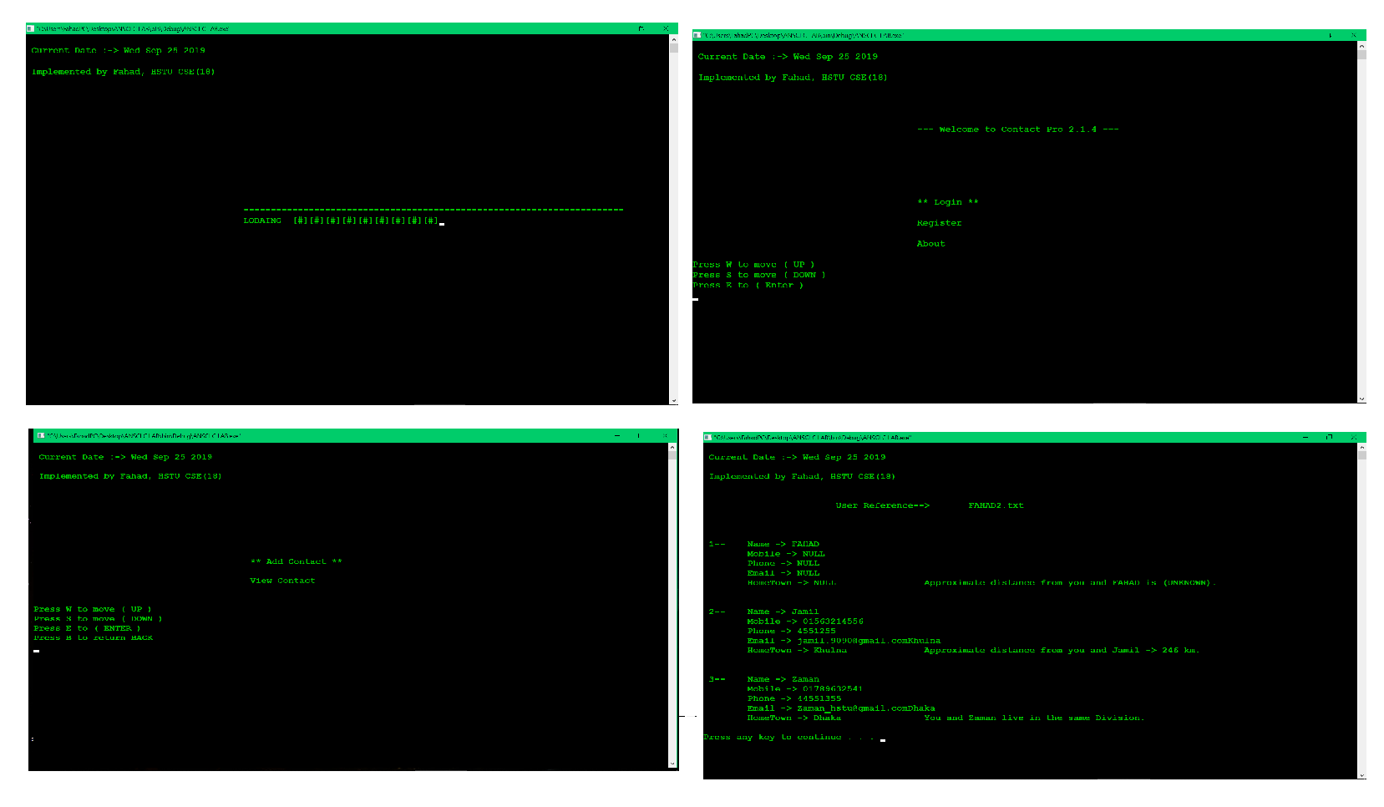

Limitations of the Project
The project is limited to 8 division of a Bangladesh. It can be upgraded to 64 districts.

Summary of the Project
This is for everyday use where people can store their contact information. It is a multi-user login system where each user will be able to store his/her contact information and also know the distance between each contact.
People of all age can use it and store their necessary contact information and also keep a track of their contacts.

